COVER, REVISION HISTORY AND APPROVAL PAGE
Revision No. | Brief Description of Change | Effectivity Date
0 | Origination

 | Name | Signature
Originated/ Revised by: | Jeffrey K. Anastacio  Project Manager | See DCN

Reviewed by: | Sherman A. Semanero  Operations Manager | See DCN
 | Virtron K. Bumal-o  Operations Manager | See DCN
 | Marjorie Laranang Olivete  Admin Director/ QMR | See DCN

Approved by: | Fernando C. Laranang  President/CEO | See DCN
Date Approved

Distribution List

President/CEO | Project Manager’s (2) | Document Controller
QMR/BOD’s | Admin (Common Copy)

- PURPOSE AND SCOPE

To develop procedures for Painting Works, ensuring proper coordination, quality control, inspection, documentation, and construction execution throughout the process, resulting to a high-quality painting works.

- REFERENCE DOCUMENTS

FCLDC Comprehensive Quality Assurance and Quality Control Program (CQAQCP)
Plans and Specifications
Contract Documents

- DEFINITIONS

3.1 Definitions

Service agreement – Contract Between the General contractor stating the date the sub-contractor can begin work subject to the conditions stated on the agreement.

Plans and Specifications - a key part of the process of constructing a project. These documents are means of communicating between parties, and of ensuring that the appropriate designs, materials and construction techniques are used.

Purchasing and Logistic Officer- the department responsible for the purchasing of materials and equipment needed for the project.

Acrytex Paint - is an acrylic, solvent-based coating that forms a seamless, non-porous, watertight film that repels water and prevents seepage

Latex Paint - a type of paint used for walls, consisting of pigment bound in synthetic latex that forms an emulsion with water.

Metal Etching Solution - is an acid type metal cleaner and rust converter. It transforms rust and removes light deposits of mill oil. It destroys corrosion stimulators and properly conditions metal surfaces for painting.

- GENERAL REQUIREMENTS

4.1 Equipment, Materials and Documents

    - Service agreement, plans and specifications
    - Certificate (NC2)
    - Computers and office supplies
    - Moisture Meter

  - Safety and Environmental

    - Each worksite and employee function are thoroughly assessed in a manner that ensures safety for themselves, property owners and representatives, the general public, and the environment.

- PROCEDURE / INSTRUCTIONS

Procedure Outline

5.1 Service agreement and Orientation

5.2 Mobilization and installation of temporary facilities and Safety requirements

5.3 Project scheduling and Material take-off

5.4 Execution and Monitoring

5.5 Inspection and Billing Report

Procedure Details

Responsible Person | Activities | Interface Document/Person
 | 5.1 Service agreement and Orientation
Finance  Project Manager | - Signing and Issuance of service agreement | Gencon and sub-con
QA/QC Engineer  Safety Officer  HR officer | - Conduct orientation on safety protocols, site rules and work hazards on the specific work.  - Orient the workers on the importance of quality control and assurance during the execution of Painting works. | Contractor  NTP
 | - Mobilization and installation of temporary facilities and safety requirements
Technical Team | - Provide space for the temporary facilities of sub-contractors including designated C.R and washing area. | Sub-contractor
 | 5.3 Project Scheduling and Material take-off
Technical Team | - Provide specific schedule for the subcontractor’s guide. | Bar Chart/S-Curve
 | 5.4 Execution and Monitoring
Site Engineer  Foreman  Subcontractor  Site Engineer  Subcontractor  Site Engineer  Subcontractor  Site Engineer  Subcontractor  Site Engineer  Subcontractor  Site Engineer  Subcontractor  Site Engineer  Subcontractor  Site Engineer  Subcontractor  Site Engineer  Subcontractor  Site Engineer  Subcontractor  Site Engineer  Subcontractor  Site Engineer  Subcontractor  Site Engineer  Subcontractor  Site Engineer  Subcontractor  Site Engineer  Subcontractor  Site Engineer  Subcontractor  Site Engineer  Subcontractor  Site Engineer  Subcontractor  Site Engineer | 5.4.1 Concrete Surfaces  5.4.1.1 New Concrete Surfaces  5.4.1.1.1 Painting Materials, Tools and Equipment  - Concrete Neutralizer  - Primer  - Concrete Putty  - Top Coat  - Sapal 2in1 By Buildrite or Equivalent  - Bostik Ultrafino Skimcoat or Equivalent  - Konstrukt Permaplast K-201 and K-202 or Equivalent  - Painless Moisture Meter  - Painter Hand Tools  - Electric Grinder  - Electric Sander  5.4.1.1.2 Material Schedule  a. Concrete Neutralizer Schedule  a.1 Boysen Product  - BOYSEN® - ® - Masonry Neutralizer B-44  a.2 Davies Product  - DAVIES 100-X Concrete Neutralizer  b. Primer Schedule  b.1 Boysen Product  b.1.1 Acrytex Paint  - BOYSEN® Acrytex™ Primer B-1705  b.1.2. Latex Paint  - BOYSEN® Permacoat™ Flat Latex B-701  c. Wall Putty Schedule  c.1 Boysen Product  c.1.1 Acrytex Paint  - BOYSEN® Acrytex™ Cast B-1711  c.1.2. Latex Paint  - BOYSEN® Masonry Putty B-7311 (interior use)  - Ultra Fino Skimcoat (interior use)  - BOYSEN® Acrytex™ Cast B-1711 (exterior use)  - Buildrite Putty Master  d. Top Coat Schedule  d.1 Boysen Product  d.1.1 Acrytex Paint  - BOYSEN® Acrytex™ Topcoat (2-3 Coats)  d.1.2. Latex Paint  - BOYSEN® Permacoat™ Latex (2-3 Coats)  e. Paint Remover Schedule  e.1 Boysen Product  - BOYSEN® Paint and Varnish Remover B-141  - BOYSEN® Chalk Blocker™ B-7304 (surface conditioner)  e.2 Davies Product  - DAVIES 500-XMildewcide Wash Solution  - DAVIES 5-530 Liquid Penetrating Sealer  - DAVIES 1350 Megacryl Concrete Primer & Sealer  - DAVIES 5000 Megacryl Concrete Putty  - DAVIES Megacryl Topcoat  5.4.1.1.3 Surface Preparation  - First, allow new concrete to cure for 14-28 days under normal weather conditions. Sometimes identifying dampness of wall can be as simple as observing it. Touching the walls to determine if they're excessively cold or wet can also help identify dampness. The general rule is that any moisture reading over 16% is considered damp and needs attention. The walls with healthy humidity levels should have a moisture reading between 12 to 15%. Moisture within and behind walls can be detected with a pinless moisture meter.  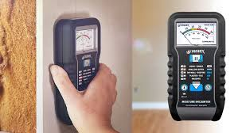  Moisture Meter  - Once dried, dust off the dirt and wipe grease or oil with a duster and dry cloth (stopha) to make sure you have a clean surface. Most important, thru thorough visual inspection, make sure that all concrete surface is totally ready to receive paint and no unsuitable surface conditions being repaired or fixed before painting.  - After curing, neutralize (or what the painters call lasunin) the surface. We neutralize the surface because the alkalinity of a new concrete surface can cause efflorescence marks on the paint, crusty, white salt deposits on wall surfaces. However, if the concrete has been cured for more than 28 days, you can choose not to apply a neutralizer.  - When neutralizing, make sure you dilute 1-liter of in 16-liters clean water. Remember to use rubber gloves when handling the solution. Then, apply it on the surface with a paintbrush or a roller and let it stand overnight before rinsing with water to remove white crystals that form on the surface. Let it dry completely before painting.  - Lightly sand the walls with a sand paper no. 60 to help ensure new paint adheres to the surface. Then, wipe away the sanding dust. Where the dents are 3-5mm deeper the filling must be done with a Konstrukt Permaplast K-202 filler paste of a thicker consistency to smoothen the surface. After K-202 has dried and hardened, scrape excess sand with no. 60 sand paper to smoothen surface. Then, wipe away the sanding dust.  6. After surface preparation, apply Primer on the surface. Apply the primer with a 7” paint brush or 7” paint roller (foam) on the total surface of the wall. Allow the primer to dry for at least 24 hours.  Note: If using a brush or roller, thin with approximately 1-Liter of Acrytex Reducer B-1750 for every 4-Liter can of Acrytex product.  After Primer application, minor imperfections and hairline cracks (non-structural cracks) would surely appear and seen on wall surface.  7. For hairline cracks equal or >2mm width, use electric grinder or spatula to widen cracks. Clean dust and particles with vacuum cleaner and duster. Fill up cracks with Sapal 2 in 1 by Buildrite or Equivalent using spatula. Let it cure for 24 hrs. After the Sapal has dried and hardened, scrape excess sand with no. 60 sand paper to smoothen surface. Then, wipe away the sanding dust  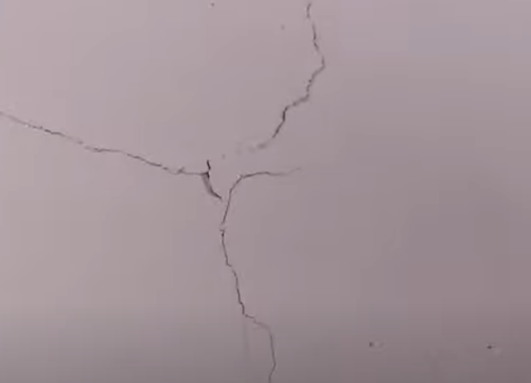  Hairline Cracks (non-structural crack)  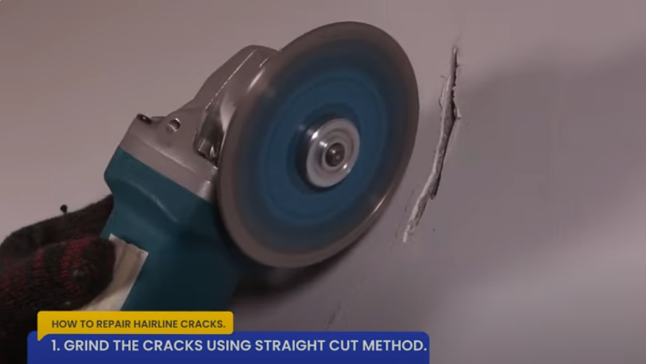  Widening of Hairline Cracks using Straight Cut Method  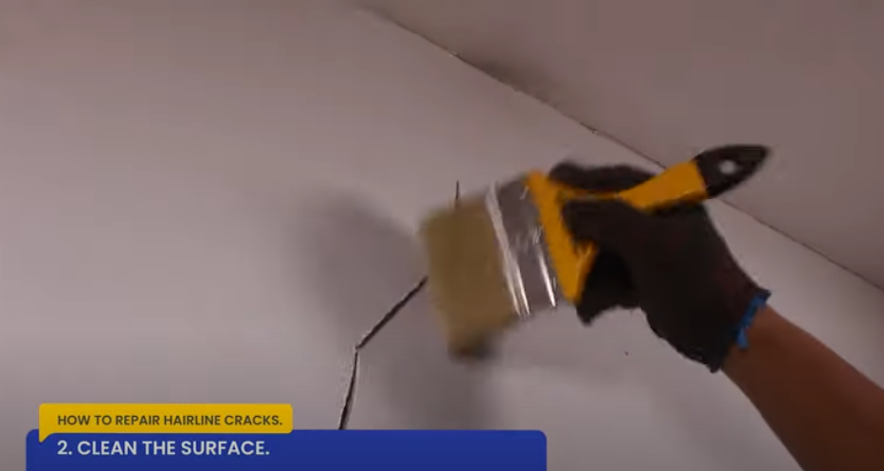  Wiping of Grinding Dust  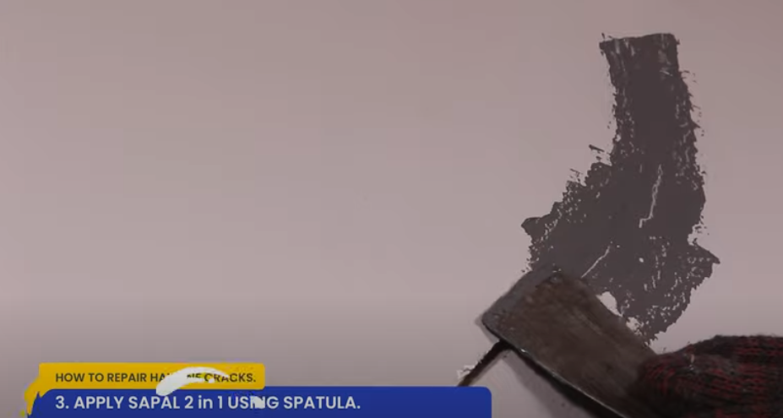  Application of Sapal 2 in 1 Using Spatula  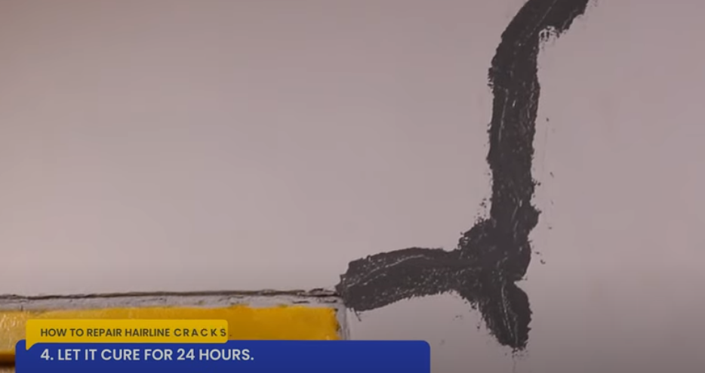  Let it Cure for 24 hours  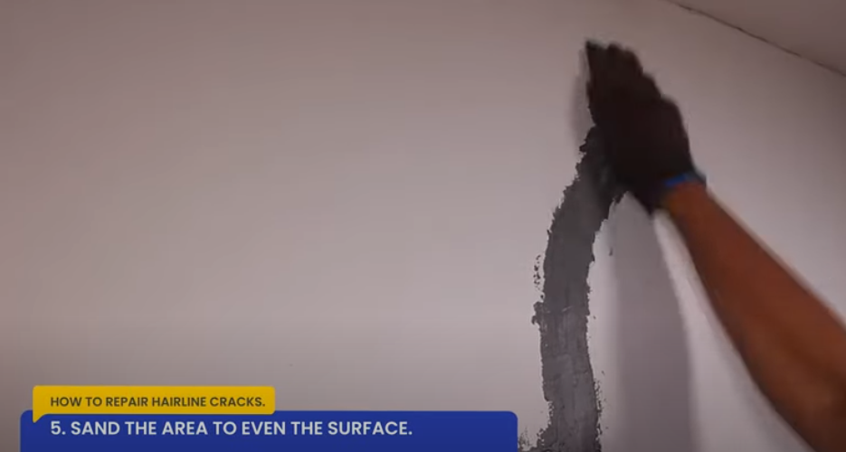  Sand the Area to Even the Surface  8.For all minor undulations with <3mm dents Fill up with wall putty so that the surface becomes completely smooth to receive paint. Spot Prime puttied portions with Primer. For smooth finish, fill all surface with wall putty “tudo batak” using a putty knife if imperfections are still not met.  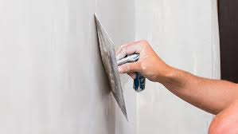  Application of Concrete Putty  9. After application of wall putty’s for wall imperfections, use power sander for large wall surface of walls to quickly and evenly, reducing the amount of time and effort required. After machine sanding, hand sanding is often used to give a final smooth finish, removing any marks or roughness left by the larger sanders. Hand sanding is ideal for reaching corners, edges, and other areas where a power sander might not fit or could damage the floor or ceiling. Then, wipe away the sanding dust.  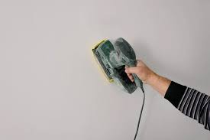  Smoothing Wall Surface using Power Sander  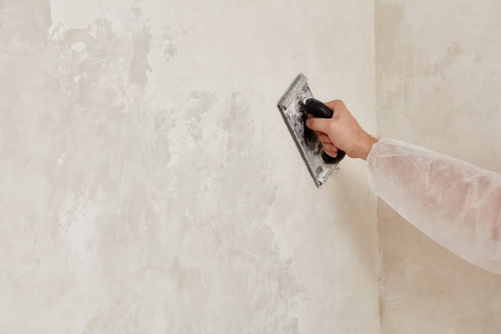  Smoothing Wall Surface using Manual Sander  5.4.1.1.3 Top Coat Application  1. Site Engineer must inspect and approve the preparations thru the painting works checklist form before starting the top coat. After the surface has been prepared and ready to receive top coat, Set Boundaries. Clear out, move away, or cover any unnecessary things where you will be painting. Apply 1” masking tape or painter’s tape to wall edges such as where the wall meets the ceiling or if there are adjacent walls you don’t want to get paint on. Cover switches, outlets and any other fixtures with masking tape or used papers. Lastly, take any scrap board “kartoon” and lay it on the floor space where you will be painting for additional protection of flooring. For Interior walls, ensure adequate ventilation, lighting and temperature conditions prior for Top Coat Application.  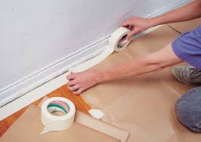  Masking Tape Installation for Boundaries  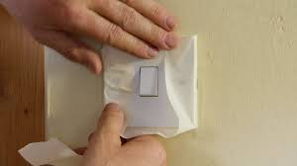  Masking Tape Covering for Electrical Switches  2.Apply surface of at least 2 Top Coat until desired finish is met depending on what has been agreed on the service agreement. Begin first coat by cutting in all edges using 2” or 4” paint brush. When all edges have been neatly coated, you can then use a 7” paint roller to paint the walls inside the edges. This can then be filled in with paint by rolling in an upwards and downwards fashion to ensure even distribution of color. In order to ensure an even application, paint should be applied to the walls in the same pattern.  3. After the first coat, ensure curing time has been met before the application of succeeding coats. Acrytex Paint (Solvent-Based Paints) can take up to 6-8 hours between the first and second coats. In any case the paint will be mixed on site, assign experienced painter to ensure the consistency of paint colors/shades are met.  4.Upon completion of work and after drying, ensure that paints are being applied evenly and there are no brush marks or color variations. A good-quality paint job gives a clear-cut separation of colors. The lines between ceiling and trims, or the ceiling and walls should be clean, straight and sharp. Check the paint at the corners of the doors, sidewall and also check the window corners. See that all stains of paint from floor, window glasses, grills, switch plates etc. have been carefully removed.  Note: It is important to monitor the work during its progress, as the entire quality of paint and its life will depend on the process.  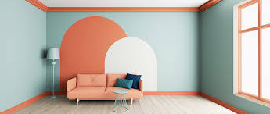  Sample Picture of a Good Quality Wall Paint  5.4.1.2 Repainting Concrete Surfaces  5.4.1.2.1 Material Schedule (5.4.1.1.2 Material Schedule)  5.4.1.2.2 Surface Preparation  1. If the film on the concrete surface still intact, simply wipe the surface clean to remove grease, dust or other dirt particles. Then, sand lightly the surface and dust off sanding particles before applying the new topcoat. Check the paint compatibility of the new paint with the old paint.  2.If the film on the concrete is not intact, any existing paint should be completely removed. Scrape off all loose, scaling, flaking, and peeling paint manually or by paint remover as necessary. Wash surfaces clean and completely remove chemical residue. Let it dry.  3. For the succeeding procedure, Refer to 5.4.1.1 New Concrete Surfaces Painting procedure.  5.4.2 Wood Surfaces  5.4.2.1 New Wood Surfaces  5.4.2.1.1 Material Schedule  a. Boysen Product  a.1 Acrytex Paint  - BOYSEN® Acrytex™ Primer B-1705 (Primer)  - BOYSEN® Acrytex™ Cast B-1711 (Putty)  - BOYSEN® Acrytex™ Topcoat (2-3 Top Coats)  a.2. Latex Paint  - BOYSEN® WoodPrime™ B-180 (Primer)  - BOYSEN® Masonry Putty B-7311 (Putty)  - BOYSEN® Chalk It™ (2-3 Top Coats)  a.3. Lacquer Enamel Paint  - BOYSEN® Lacquer Primer Surfacer B-305 (1st Coat)  - BOYSEN® Lacquer Spot Putty B-306 (2nd Coat)  - BOYSEN® Lacquer Primer Surfacer B-305 (3rd Coat)  - BOYSEN® Automotive Lacquer B-1300 or BOYSEN® Gloss Lacquer Enamel B-1200 (Final Coat)  a.4. Epoxy Enamel Paint  - BOYSEN® Epoxy Primer White B-2200 or  - BOYSEN® Epoxy Primer Gray B-2230 (Primer)  - BOYSEN® Epoxy Enamel. (Top Coat)  a.5. Wax-Based Paint  - BOYSEN® Paint and Varnish Remover B-141 (Paint Remover)  b. Davies Product  b.1. Latex Paint  - DAVIES 1350 Megacryl (Primer)  - DAVIES 5000 Megacryl (Putty)  - DAVIES Megacryl (2-3 Top Coats)  c. ABC Product  - Gypsum Putty  d. Buildrite Product  - Buildrite Putty Master  5.4.2.1.2 Surface Preparation  1.Choose kiln-dried wood. It is recommended to use kiln-dried wood that went through a drying process that thoroughly removes the excess moisture from the wood.  2. Get a clean and smooth surface. Punch in all nail heads and apply putty. Then, sand it down to achieve a smooth surface. Finally, wipe the surface with a clean rag to eliminate sanding dust or dirt particles and to make sure to have a clean surface.  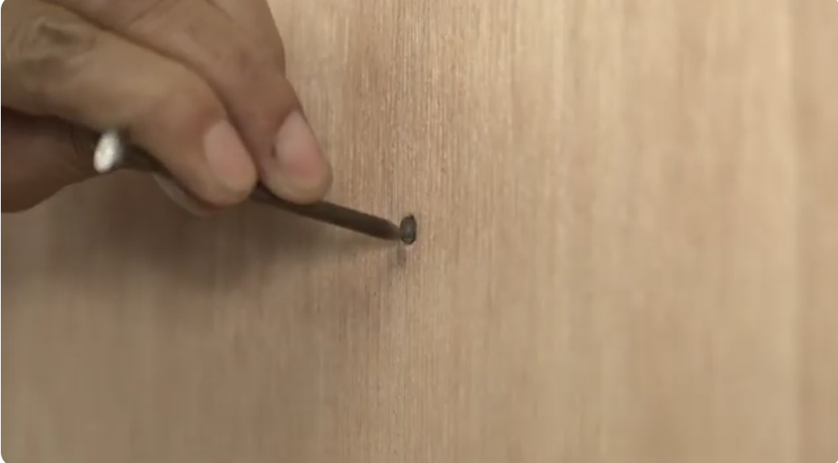  Punching of Nail Heads  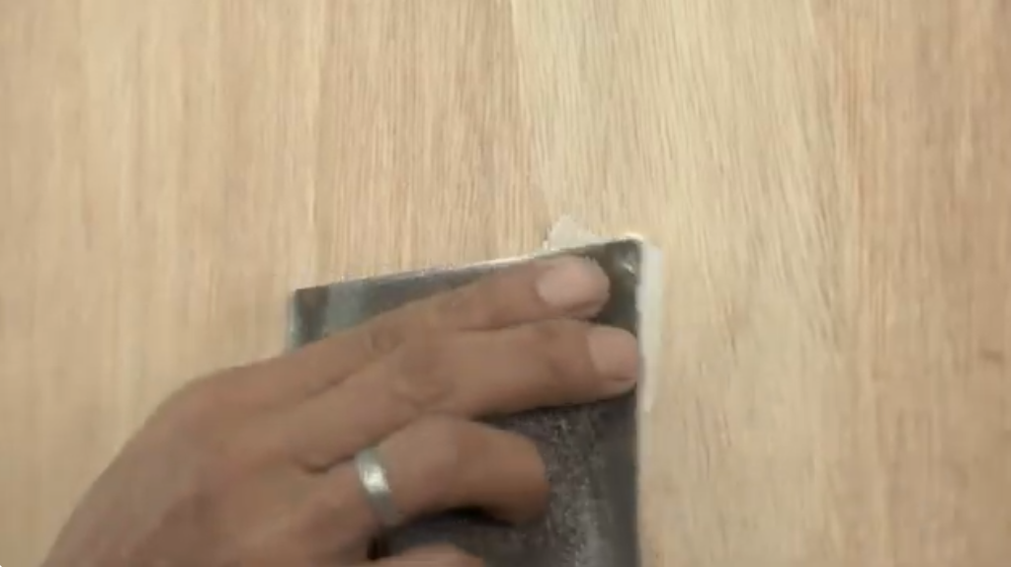  Application of Wood Putty on Punched in nail head  5.4.2.1.3 Primer and Top Coat  1. For Primer and Top Coat application, Refer to 5.4.2.1.1 Material Schedule.  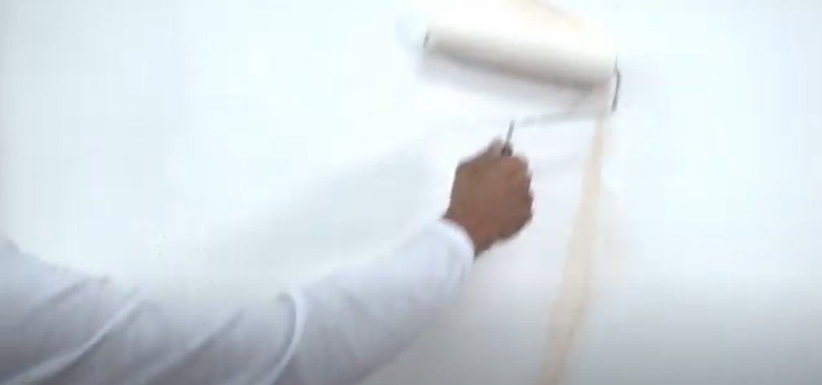  Primer Application  5.4.2.2 Repainting of Wood Surfaces  5.4.2.2.1 Material Schedule (Refer to 5.4.2.1.1 Material Schedule )  5.4.2.2.2 Surface Preparation  1. First, check the condition of the old paint on the wood. Old paint is still in good condition if the paint film still adheres to the wooden surface. If that’s the case, sand lightly the surface and dust off the sanding particles.  2. If the paint is loose, cracking, and peeling, then eliminate any trace of paint using a scraping tool. Then, sand it down to have an even yet coarse surface that will help the paint to cling to the surface. Lastly, wipe dust or dirt particles completely with a damp clean rag.  3. When the surface is clean and dry, start painting. Start by applying the primer on bare surfaces. Next, cover hairline cracks and minor surface imperfections with putty. Then, apply the topcoat.  5.4.2.2.3 Primer and Top Coat  1. For Primer and Top Coat application, Refer to 5.4.2.1.1 Material Schedule.  5.4.3 Metal Surfaces  5.4.3.1 New Metal Surfaces  5.4.3.1.1 Material Schedule  a. Boysen Product  a.1 Acqua Epoxy Paint  - BOYSEN® Epoxy Primer White B-2277 or  - BOYSEN® Epoxy Primer Gray B-2230 (Primer)  - BOYSEN® Acqua Epoxy (Top Coat)  a.2 Quick Dry Enamel Paint  - BOYSEN® Red Oxide Metal Primer B-310 or  - BOYSEN® Rust-Off™ B-330 (Primer)  - BOYSEN® Quick Drying Enamel (Top Coat)  a.3 Roofgard Paint  - BOYSEN® Red Oxide Metal Primer B-310 or  - BOYSEN® Rust-Off™ B-330 (Primer)  - BOYSEN® Roofgard (Top Coat)  a.4 Paint Remover  - BOYSEN® Metal Etching Solution B-71  b. Davies Product  b.1. Aqua Epoxy Paint  - DAVIES 1390 Aqua Metal Primer (Primer)  - DAVIES 5000 Megacryl (Putty)  - DAVIES Megacryl (2-3 Top Coats)  5.4.3.1.2 Surface Preparation  1. Wipe the surface with a rag soaked in paint thinner to eliminate grease, oil, wax, or other contaminants. Then, prepare an etching solution. Spread the etching solution on the surface and let it sit for 10-15 minutes. Rinse with water and dry right away. Apply primer straight away to prevent rust from forming again.  Note: For G.I sheets, You don’t need to etch the surface if it has been exposed for 6 months or more.  5.4.3.1.1.2 Primer and Top Coat  1. For Primer and Top Coat application, Refer to 5.4.3.1.1 Material Schedule  5.4.3.2 Rusty and Unpainted Metal Surfaces  5.4.3.2.1 Material Schedule (Refer to 5.4.3.1.1 Material Schedule )  5.4.3.2.2 Surface Preparation  1. Check for rust and treat it before painting. Remove rust using a steel brush or a rough sanding paper. If there’s still stubborn rust even after sanding, you should apply pure etching solution on rusty areas. Let it stand for 10-15 minutes. Then, wash it off and dry it. Apply primer straight away to prevent rust from forming again.  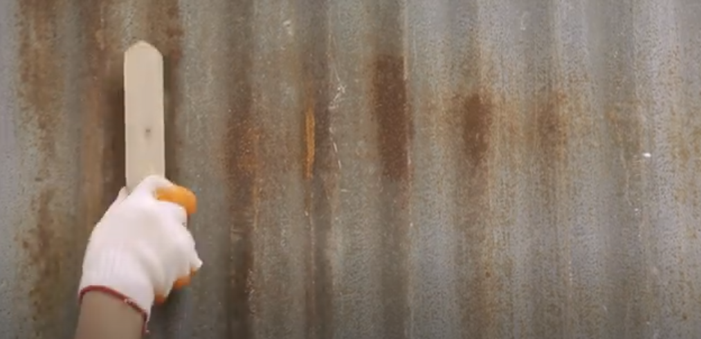  Removing of rust using steel brush  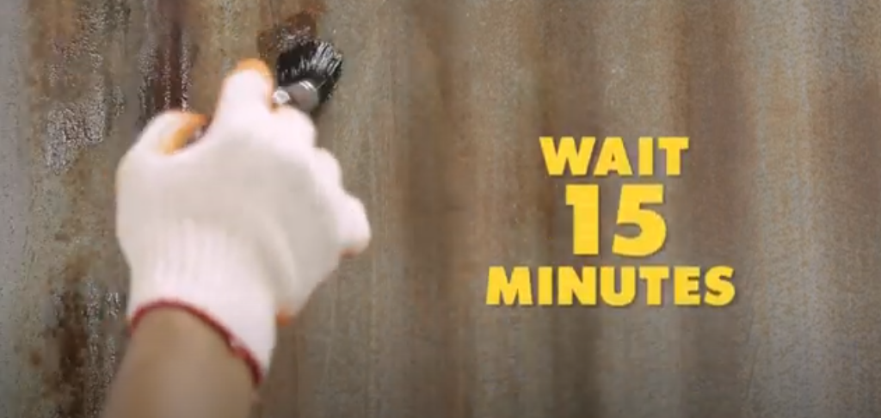  Application of Etching Solution  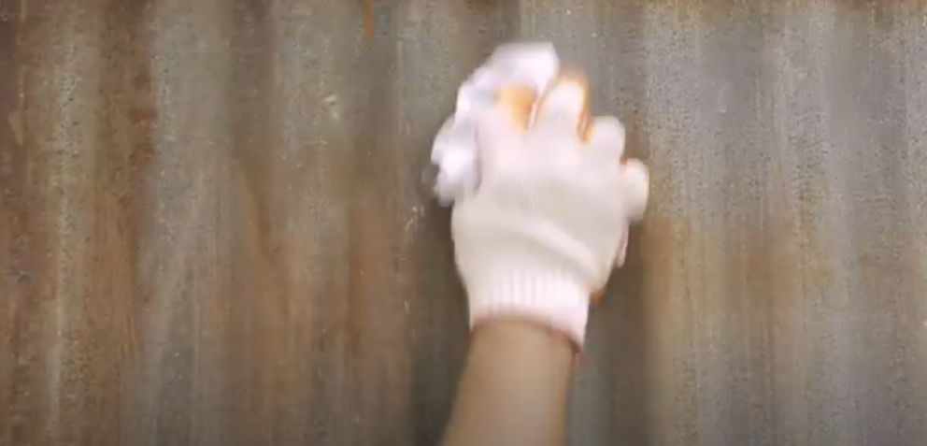  Wipe dust particles completely with a damp clean rag.  5.4.3.2.3 Primer and Top Coat  1. For Primer and Top Coat application, Refer to 5.4.3.1.1 Material Schedule .  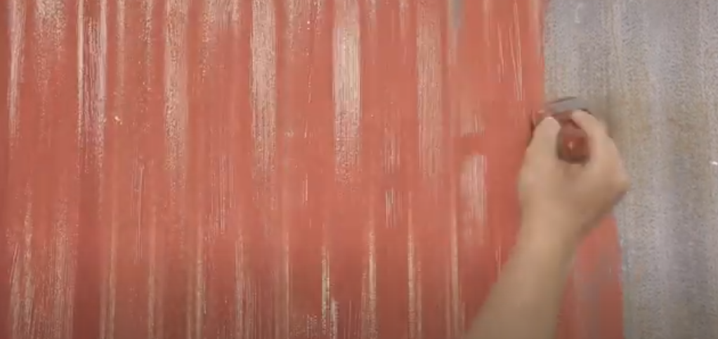  Application of Primer  5.4.3.3 Repainting Metal Surfaces  5.4.3.3.1 Material Schedule (Refer to 5.4.3.1.1 Material Schedule )  5.4.3.3.2 Surface Preparation  1. If the film on the metal surface still intact, simply wipe the surface clean to remove grease, dust or other dirt particles. Then, sand lightly the surface and dust off sanding particles before applying the new topcoat. Check the paint compatibility of the new paint with the old paint.  2. If the paint is loose, cracking, or peeling, then eliminate any trace of paint using a scraping tool. Then, wipe dust particles completely with a damp clean rag.  3. After that, remove loose rust with a wire brush and sanding paper. If there are still stubborn rust after sanding, apply pure etching solution on rusty areas. Let it sit for 10-15 minutes. Then, rinse it with water to remove acid residue and dry it with a clean rag. Apply primer immediately to avoid rust from forming again.  5.4.3.3.3 Primer and Top Coat  1. For Primer and Top Coat application, Refer to 5.4.3.1.1 Material Schedule .  5.4.4 Drywall Surface  5.4.4.1 Fiber Cement Board  5.4.4.1.1 Material Schedule  a. HardieFlex Nexgen Product  - HARDIE Putty Joint Compound  - HARDIE Perforated Paper Tape  b. Boysen Product  b.1 Latex Paint  - BOYSEN® Permacoat™ Flat Latex B-701 (Primer)  - BOYSEN® Masonry Putty B-7311 (interior use)  - Ultra Fino Skimcoat (interior use)  - BOYSEN® Acrytex™ Cast B-1711 (exterior use)  - BOYSEN® Permacoat™ Latex (2-3 Top Coats)  - Konstrukt™ Durafill™ K-103 (Putty)  - Konstrukt™ Durafill™ K-101 (Putty)  b.2 Acrytex Paint  - BOYSEN® Acrytex™ Primer B-1705 (Primer)  - BOYSEN® Acrytex™ Cast B-1711 (exterior use)  - BOYSEN® Acrytex™ Topcoat (2-3 Top Coats)  c. Buildrite Product  - Buildrite Putty Master  d. ABC Product  - Gypsum Putty  e. Butterfly Product  - Butterfly Fiberglass Mesh Tape Self Adhesive  5.4.4.1.2 Surface Preparation  1. Fill head screw hole with putty. Then, smooth over the surface with a drywall knife. Apply wall putty on drywall gaps as a base coat and bonding agent of drywall paper tape using putty knife. Apply drywall paper tape on the base coat. Ensure there is no voids at bottom of the tape. Apply wall putty on the applied tape as a second coat to make sure that the tape is thoroughly sealed. Then, smooth over the surface with a drywall knife.  2. When it’s been successfully prepped and the joints have been secured, sand the surface lightly to get a smooth finish and to help the paint to adhere better on the surface. Wipe the surface with a clean rag to remove dust particles.  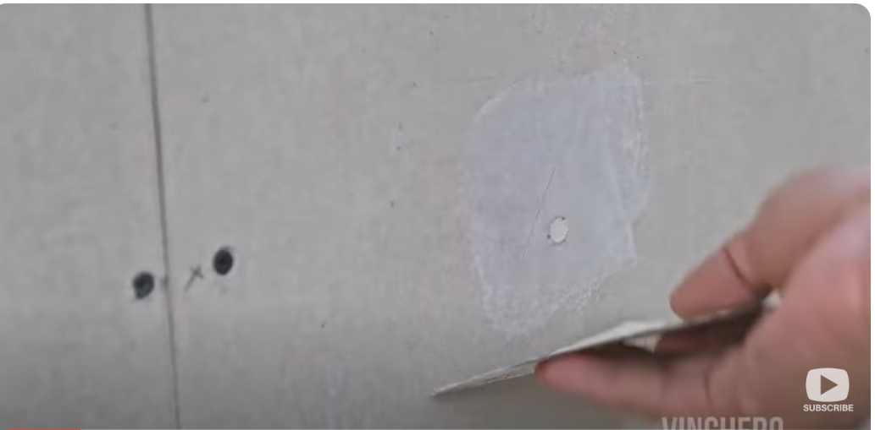  Application of Putty on Screw Head Holes  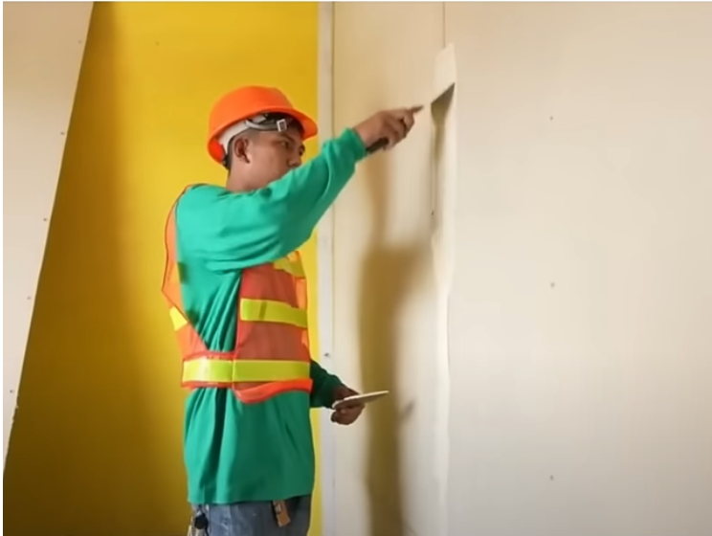  Application of Putty as base coat on Wall Gap Connection  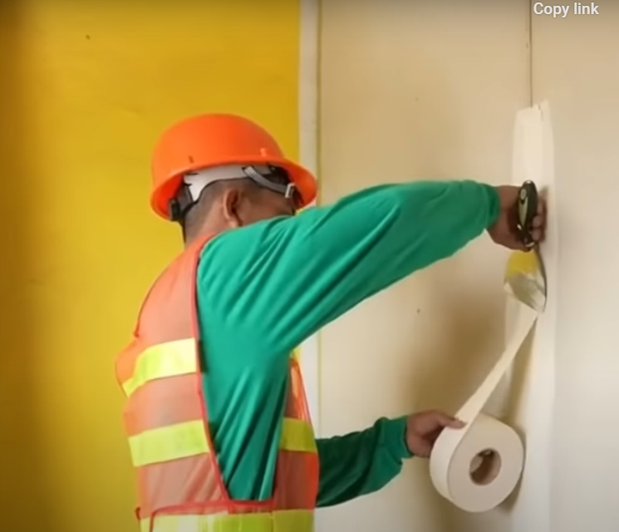  Application of drywall paper tape on base coat Wall Gap Connection  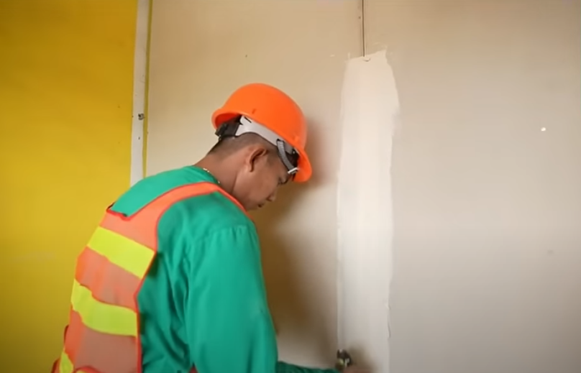  Application of Putty as 2nd coat on paper tape Wall Gap Connection  5.4.4.1.3 Primer and Top Coat  1. For Primer and Top Coat application, Refer to 5.4.4.1.1 Material Schedule .  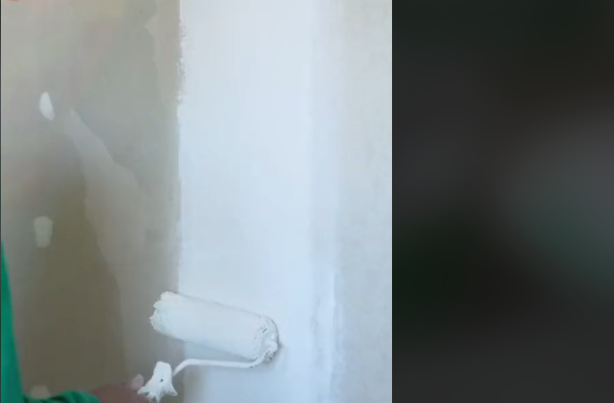  Primer Application  5.4.4.2 Gypsum Board  5.4.4.2.1 Material Schedule (Refer to 5.4.4.1.1)  5.4.4.1.2 Surface Preparation  1. Tighten the black screw using screw driver. Level head of the black screw with the use of pallete to ensure it will not appear when putty is applied. Fill head screw hole with putty. Then, smooth over the surface with a drywall knife. Apply mesh tape on the drywall gap. Apply gypsum putty on the applied tape as a binder to secure the reinforcing tape. Then, smooth over the surface with a drywall knife.  2. When it’s been successfully prepped and the joints have been secured, sand the surface lightly to get a smooth finish and to help the paint to adhere better on the surface. Wipe the surface with a clean rag to remove dust particles.  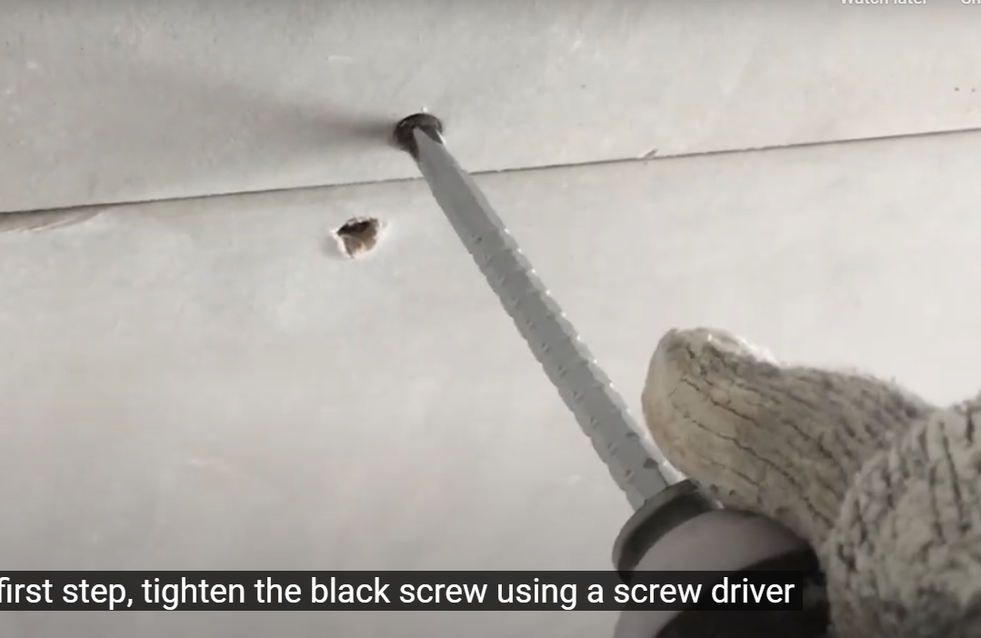  Tighten screw using screw driver  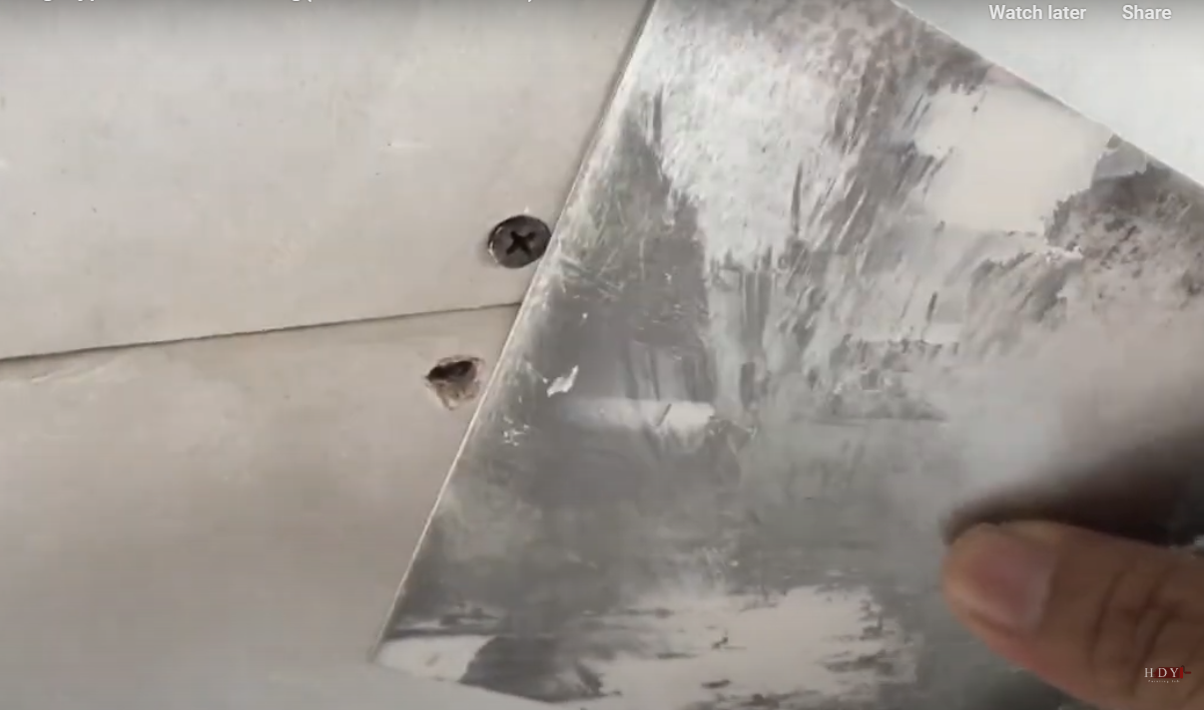  Check screw level using pallete  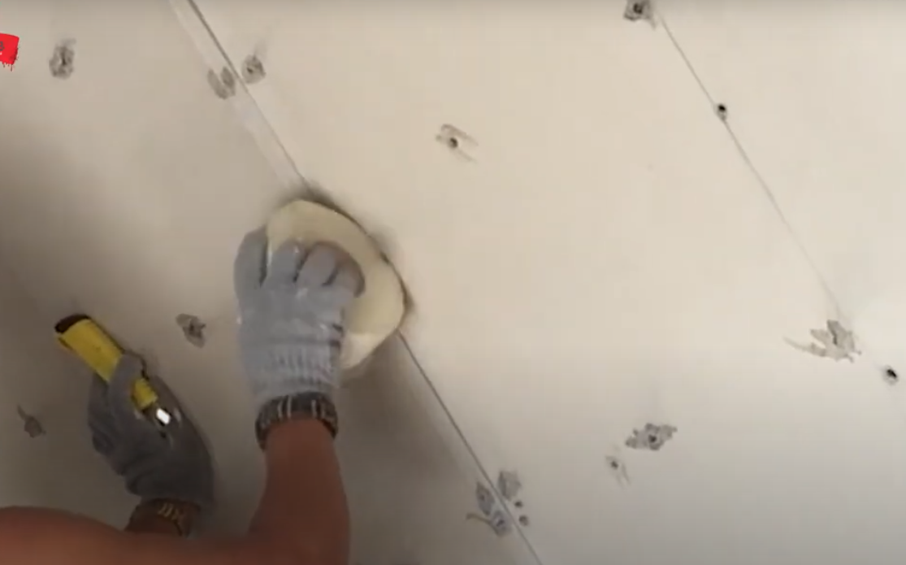  Application of Gypsum Mesh Tape  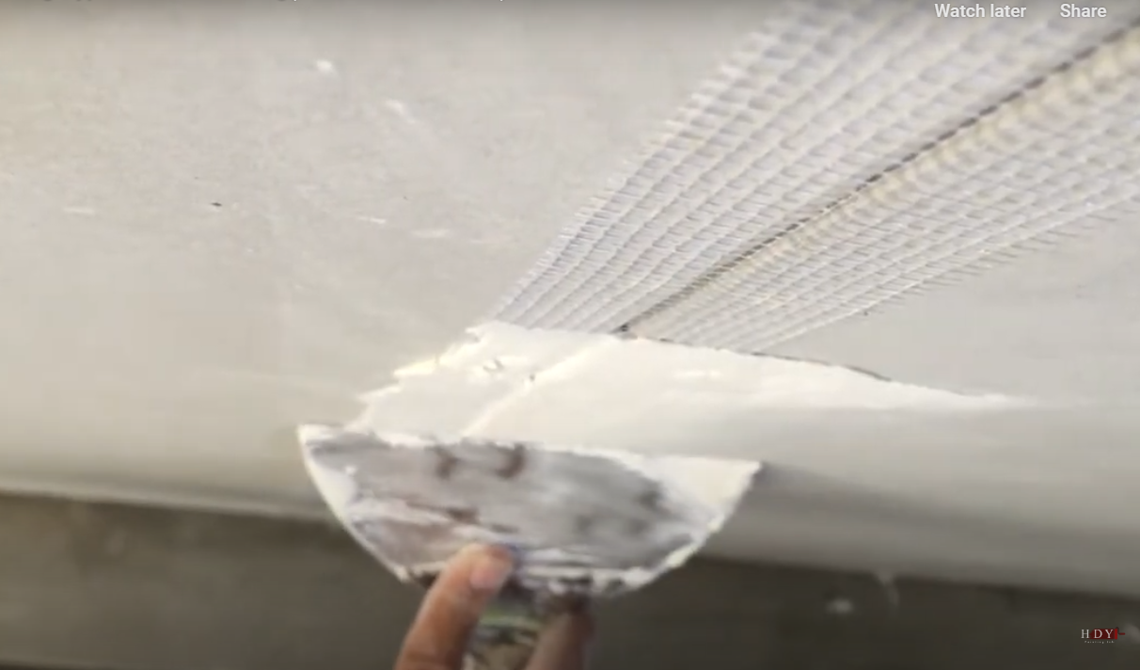  Application of Gypsum Putty  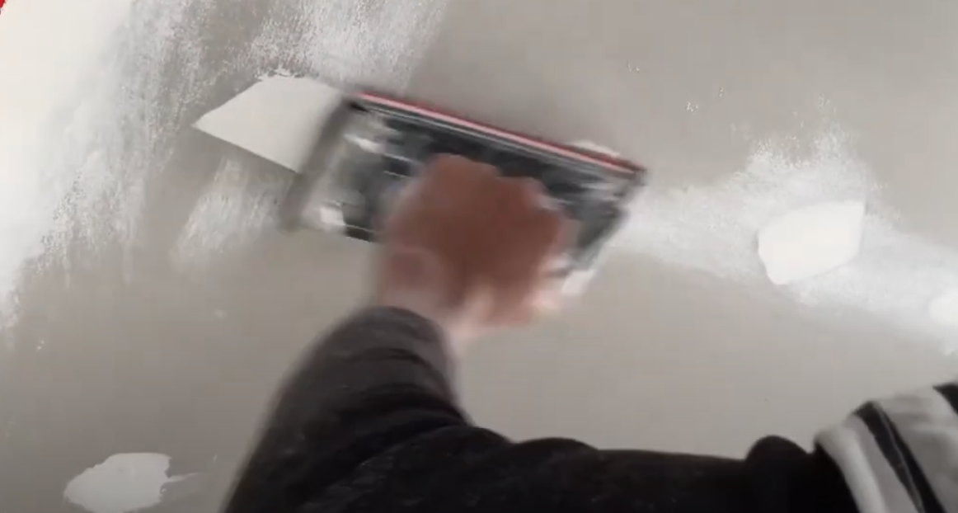  Manual Sanding of Hardened Putty  5.4.4.2.3 Primer and Top Coat  1. For Primer and Top Coat application, Refer to 5.4.4.2.1 Material Schedule .  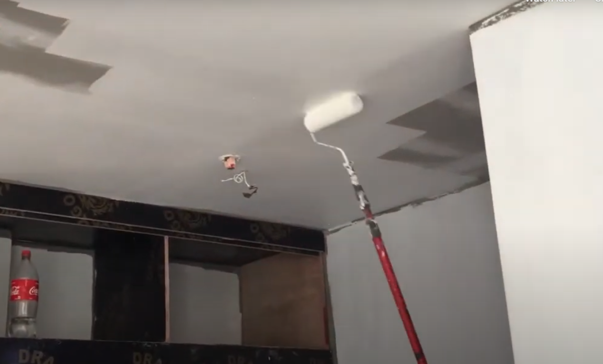  Primer Application | Painting Works Checklist Form  Painting Works Checklist Form  Painting Works Checklist Form  Painting Works Checklist Form  Painting Works Checklist Form  Painting Works Checklist Form  Painting Works Checklist Form  Painting Works Checklist Form  Painting Works Checklist Form  Painting Works Checklist Form  Painting Works Checklist Form  Painting Works Checklist Form  Painting Works Checklist Form  Painting Works Checklist Form  Painting Works Checklist Form  Painting Works Checklist Form  Painting Works Checklist Form  Painting Works Checklist Form  Painting Works Checklist Form
Site Engineer  Subcontractor | 5.5 Inspection and Billing Report  - After 7 days, the Site Engineer and the subcontractor inspect and measure the work done for billing report, the site engineer double check the surface if it has met the quality as per standard with reference to the painting works checklist form.  - The Site Engineer should check the quality of painting work carefully both in daylight as well as in artificial light, so as to get the idea of aesthetics in both types of lightings. It is recommended to use flash lights or flood lights for inspection to check for spots of wall undulations. This is to follow thru and to verify if corrections and comments on the work were properly address by the subcontractor.  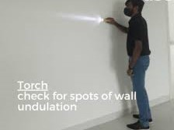  Checking spots of wall undulations  - Inspected work with rectification will not be included in the billing until such repair is done by the subcontractor.  - Labor cost for all defects shall be at the expense of the subcontractor  In case the defect is not rectified; the admin will do the rectification and all labor cost incured therein will be deducted from the retention of the subcontractor.  Note: refer to the billing procedure stated on the service agreement  Reference:  - Boysen Painting 101: The Basics of Using Boysen Products  - https://www.youtube.com/@BUILDRITECONSTRUCTIONCHEMICALS (Repairing Hairline Cracks and Why They Appear on Window and Door Corners)  - Hardie™ Putty Joint Compound and Hardie™ Perforated Paper Tape  https://www.youtube.com/@jameshardieph  - Paano Pinturahan ang Gypsum Board Ceiling(actual demo on ... | Service Agreement  Subcon Billing

6.0 APPENDICES

Service Agreement

PM-OPN-02-16 Painting Works Checklist form

Billing form

